RE-USABLE BOTTLE BAG – Lined Bag
This write-up is based on a 70cl wine bottle (covers bottle): 17” x 7”
Length 17”, Width 7”
Cut out 4 pieces: 2x main fabric (outside), 2x lining (inner)
Starting with the MAIN fabric pieces, place fabric right sides together (wrong side of fabric faces up), add a mark 2 1/2” down from the top on both edges and then again another 1” below – this will be your casing for the drawstring. Pin together.
Once marked, sew around 3 sides of MAIN fabric together using a 1cm sewing allowance, leaving the gaps unstitched and the top open.

Moving on to the LINING piece, sew around the 3 sides, leaving a gap of 3cm or so at the bottom (turning hole) and leaving the top open.
Iron each of the pieces flat, separating the seam allowance out with the iron to reduce bulk. This also aids with a smoother casing at the end.
----------
BOXED corners (optional)
On the MAIN fabric piece, start at the bottom edges and mark 1.5 inch corners out at each side.
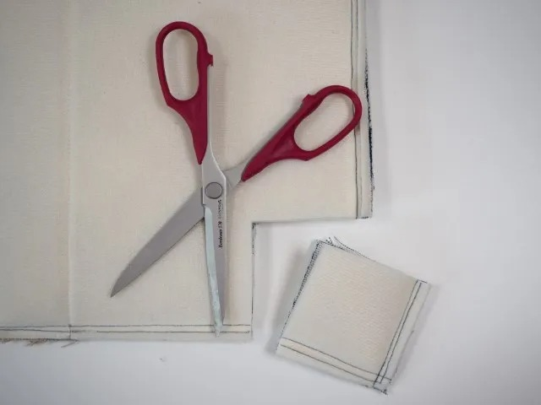
Cut out the corners through the stitches.
Do the same on the LINING pieces.

Once you have cut these out, pull the corners apart to line up the edges and bottom/side seams.
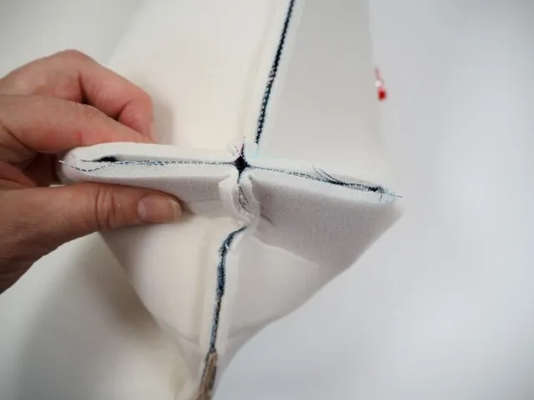
Flatten onto the table and stitch across the raw edges. Do this for each bottom corner.
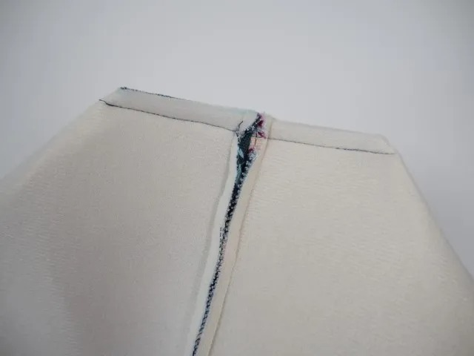
-------
With MAIN fabric piece still inside out (wrong side facing up), turn the LINING piece the right way out and then stuff it inside the MAIN piece. Match seams up for a perfect fit.
Once your seams are lined, pin or clip around the top edge. Sew together & then pull through turning hole.
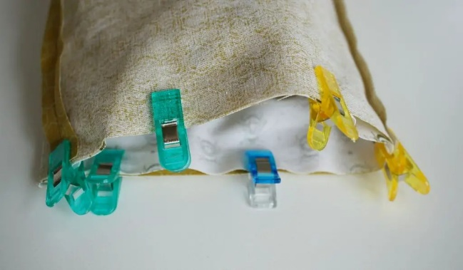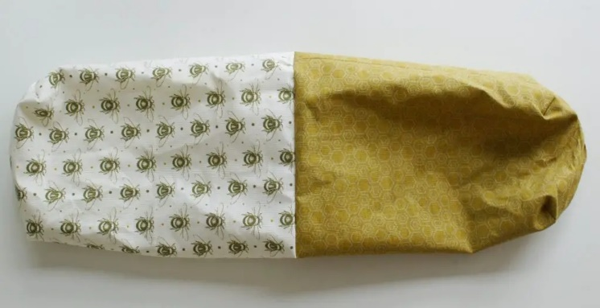
Sew turning hole shut, then stuff LINING back inside the MAIN fabric to make your bag.
IRON the bag down, making sure the LINING isn’t showing on the outside.
From the holes left in the sides of your bag, mark lines, with a ruler, from one edge to the other at the top & bottom of the side holes. This is so you have a guide to sew your casing.
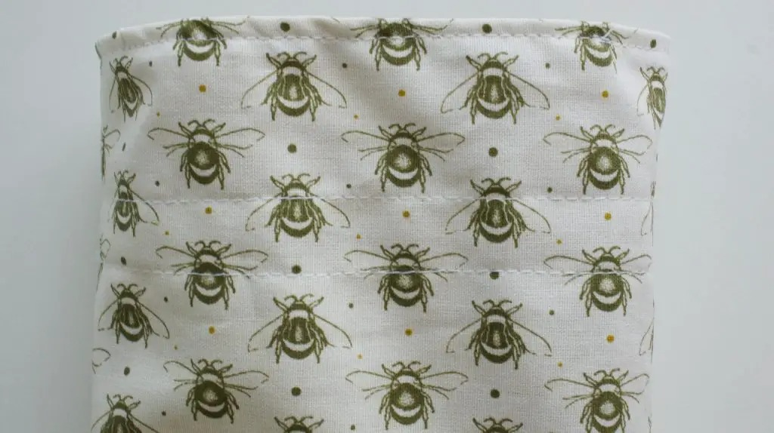
Sew all the way around, backstitching to start and finish.
Lastly, it’s time to thread the ribbon around the bag!
Cut 2x pieces of ribbon – measure these by gauging a length of ribbon against the width of the bag, then doubling it.
Cut here for your first piece. Now, use this piece as a guide to cut your second section.
Using a safety pin, attach the pin to the end of one piece of ribbon. Thread from one side and all the way round past the opposite hole to come out of the same side you started. Now repeat this on the other side.
Pull the ribbons outwards to draw the bag in and tie a lovely bow!
*pictures do not belong to Lairg & District Learning Centre, they are for illustrative purposes only.

